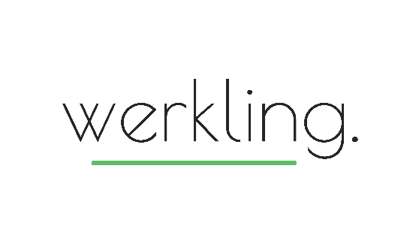
Development Plan

The what
What is one knowledge area that would benefit from some fresh thinking?

What will I read, listen to or attend? | Who will I talk to or partner with? | How will embed learning in a project?
By: | By: | By:

What is one knowledge area that I know nothing about (but should know a little!)?

What will I read, listen to or attend? | Who will I talk to or partner with? | How will embed learning in a project?
By: | By: | By:

The how
What is one behavioural nudge that will give my clients an even better experience?
Where I am today? | Where do I want to be?

My new micro-habit

Where can I go for some coaching, advice or feedback?

